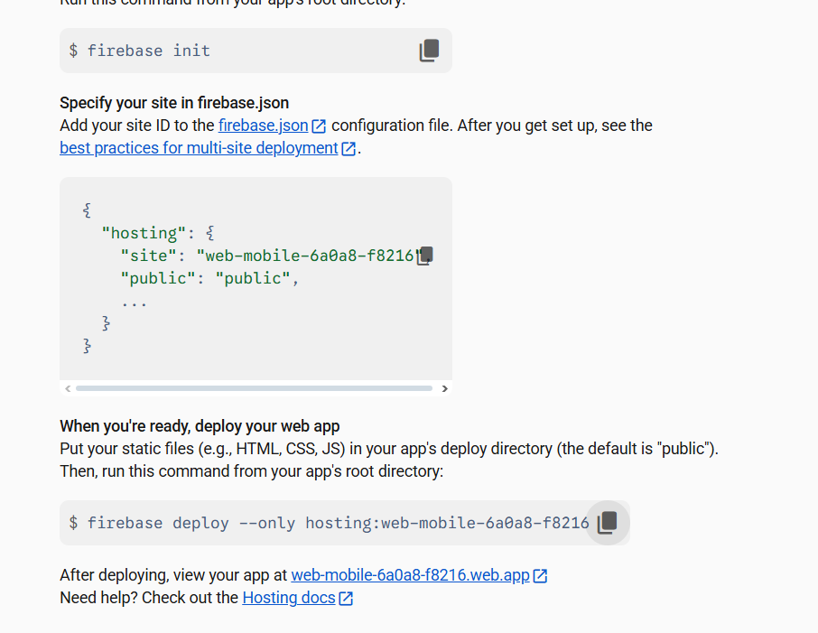
firebase login

firebase init

"site": "web-mobile-6a0a8-f8216",

firebase deploy --only hosting:web-mobile-6a0a8-f8216

